Closing Song: “This Is My Father’s World” (UMH 144)
Closing Prayer: Gracious and guiding God, You send us into the world with purpose, courage, and hope. As Scouts, leaders, families, and followers of Christ, help us carry Your light into every place we go. Strengthen our moral compass so that our choices reflect Your love, our actions honor Your calling, and our lives bear witness to Your grace. As we leave this time of worship, go before us to lead us, beside us to guide us, and within us to sustain us. In the name of Jesus Christ, our Light and our Way. Amen.
Scout Commissioning and sending:
Leader: Scouts, today we affirm your commitment to learning, service, and leadership. Will you seek to be trustworthy, helpful, and guided by God in all you do?
Scouts: We will, with God’s help.
Leader: People of God, will you support these Scouts with your prayers and encouragement?
Congregation: We will, with God’s help.
Leader: May God guide you, strengthen you, and lead you in the way of service and love. Amen.
Pastor:
May the God who lights our path go before us to guide our steps, beside us to steady our hearts, and within us to give us courage. May Christ, our true North, lead us in the way of love and service. And may the Holy Spirit empower us to be people of character, hope, and compassion in all we do. Go in peace, to serve God and neighbor. Amen.
“Start children off on the way they should go,
and even when they are old they will not turn from it.
Proverbs 22:6 (NIV)
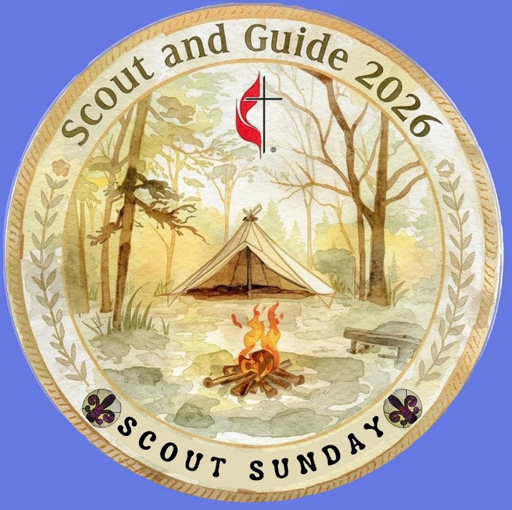
Call to Worship
Leader: God calls us to walk paths of courage, service, and integrity.

People: We come seeking direction for the journey ahead.

Leader: Just as a compass points true north, Christ points us toward love, justice, and truth.

People: Just as a map guides our steps, Scripture shapes our choices.

Leader: On this Scout Sunday, we give thanks for the tools that guide us — in the wilderness and in life.

All: Lead us, O God, as we follow Your way.
Prayer
Holy and gracious God, You have given us the tools we need to walk faithfully in this world. You place a compass in our hearts — the presence of Your Spirit — and You give us a map in Your Word, so that we may choose paths of kindness, courage, and service. Bless the Scouts, leaders, families, and all who gather today. Teach us to follow Your direction and trust Your guidance. In the name of Jesus Christ, our Guide and Shepherd. Amen.
Hymn “Be Thou My Vision” (UMH 451)
Old Testament Reading Psalm 119:105 “Your word is a lamp for my feet, a light on my path.”
Testament Reading John 8:12
“When Jesus spoke again to the people, he said, “I am the light of the world. Whoever follows me will never walk in darkness, but will have the light of life.”
Sermon Thought- from Chris Karabinos, North Georgia Conference Scouting Coordinator
Who here is familiar with these items? (graphic shows a map and compass) What are they used for?
Right, a map and compass are used to guide you as you go from one place to another outdoors, usually in the woods. The red end of the compass needle always points North which provides a reference point as you are figuring out which way to go. A compass is especially helpful if you are lost in the woods and need to find your way to a safe place. Cub Scouts, Boy Scouts, and Girl Scouts will use a map and compass outdoors to help them navigate their way around difficult obstacles, like mountains and streams, and to help them make difficult choices as to which way to turn.
The idea of a compass to help you find your way through challenges can also be used in your everyday life. Like a real compass, Scouting uses a concept we’re familiar with called a moral compass. A moral compass is a compass inside your head and heart that helps you make a choice when you are faced with a difficult decision. But instead of pointing North like a physical compass, your moral compass points toward a set of “values” that guide you as you make decisions. Your values might include: telling the truth (or not), being nice or helpful to others (or not), following the 10 Commandments, following and trying to act like Christ.
A moral compass is especially helpful when you have difficult decisions to make, such as “Do I repeat gossip I’ve heard about a competing executive as we jockey for the same promotion?”, or “Do I hang around at the end of the network association’s cocktail reception when a really attractive woman flirts with you?” Or for a Scout, the questions may revolve around cheating on tests, being honest with friends and helping their parents and siblings out.
Someone with a good, strong moral compass might pray to Jesus for guidance and assistance when they have trouble deciding on a course of action.
This idea of installing a set of values into youth while playing outdoor games started over 100 years ago, in 1907 in England. And the compass was intentionally selected to be a game piece, as well as a teaching tool. Boys join Boy Scouts for fun and games, while parents want them to join to learn new ideas and values.
The foundational elements of Scouting are rooted in faith. This is why the UMC established an official partnership with the BSA in February 1910 via a charter agreement and has maintained it since. We celebrated the 100th anniversary of this partnership in 2020.

